Chip Budding Technique – Excerpts
Excerpt from Penn State Extension article, “Fruit Tree Propagation – Grafting and Budding”
Chip Budding
Chip budding is a technique that can be used whenever mature buds are present and the bark is not slipping. It can be done in the spring before growth starts and when the stock and the scion are still totally dormant. Chip budding is generally used when the stock and scion are relatively small (1/2 to 1 inch in diameter). In recent years, most commercial tree fruit nurseries have changed from T-budding to chip budding because the buds tend to grow out better.
In chip budding, the first cut is made below the bud and down into the wood at an angle of 30 to 45 degrees (Figure 14). The second cut is started about 1 inch above the bud and goes inward and downward behind the bud until it intersects the first cut.
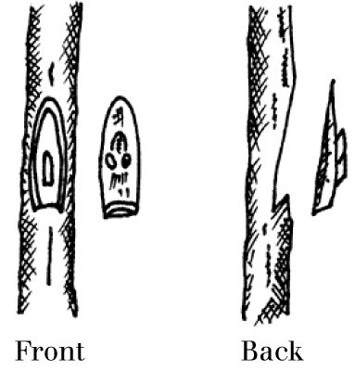
Figure 14. Chip budding cuts.
The same procedure is then followed on the stock, making sure to match the size of the "chip" cut from the budstick.
Unlike the T-bud, there are no protective flaps to keep the chip bud from drying out. Therefore, securely wrapping the bud is necessary to seal the cut edges, as well as to hold the bud piece in place. Nursery workers' adhesive tape works well, although white or transparent plastic tape is more often used. Once the buds start to grow, the tape must be cut.
In chip budding the stock is not cut back above the bud until the union is complete. If the bud is inserted in the fall, the stock is cut back just before growth starts the next spring. If the budding is done in early spring, the stock is cut back about 10 days after the bud has been inserted.
Note on collecting and storing dormant buds from U. of Nebrask “G03-1518 Chip Budding”:
Dormant budwood is cut from dormant stock plants during the winter months (after leaf-fall and up to four to six weeks before bud break), with mid-March being the best time in the Midwest (Z5). This scionwood is also wrapped in slightly moist paper and stored in polyethylene bags in refrigerated storage between 30o and 32o F (-1o to 0o C) for two to three months until spring when the understocks are ready to bud. This practice allows the commercial grower a longer period to bud the crop since the new growth on the plants in spring seldom has mature enough buds for budding purposes until late June (Nebraska, Z5).
Diagram on Chip Budding from U. of Nebraska “G03-1518 Chip Budding”:
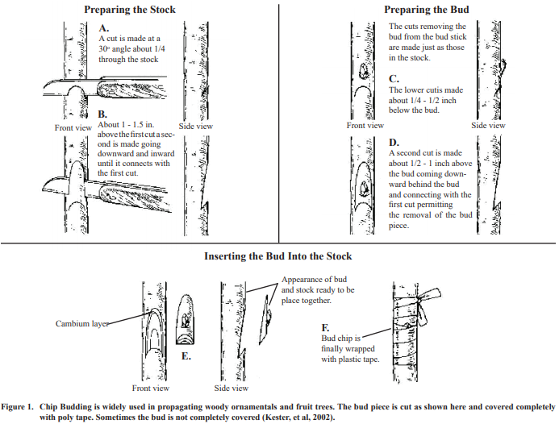
The above diagram is also found on page 520 in the Hartmann textbook (Plant Propagation: Principles and Practices), along with some excellent photos (google “Techniques of Budding-Aggie Horticulture”)
Diagram from University of Kentucky, “Reproducing Fruit Trees by Graftage: Budding and Grafting”: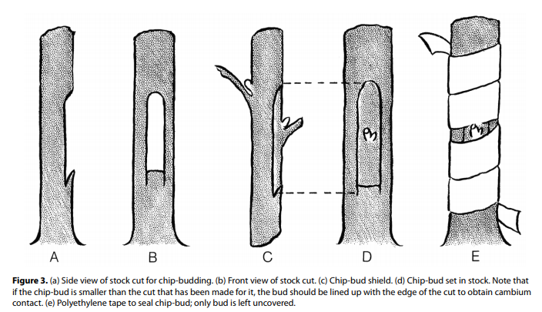
Excerpt from You Tube discussion “Chip Bud Grafting” by Salt Spring Apple Company:
REPLY
Salt Spring Apple Company1 year ago
The information I provided was specifically about the chip bud grafting procedure. When we started out, we didn't have much scion wood to work with, so we only did the chip bud grafting in order to maximize the number of trees we were able to make. Since then, as we have better access to scion wood, we have slowly shifted to more whip & tongue than chip bud in the spring because we find that the growth rate in the first year is higher with whip & tongue spring grafts. We have always summer grafted using chip bud. We have also found that a significant number of our spring chip buds heal, but don't sprout or show significant growth in the first year -- making it seem that our take rate is quite low. However, if you allow the buds to overwinter (as what we have taken to call sleeping eyes), the success rate becomes quite high. Hope that helps to answer your question more fully.

Excellent color pictures and instructions:
https://courses.cit.cornell.edu/hort494/mg/methods.alpha/ChipMeth.html
Excellent You Tube: “Chip Bud Grafting” by Salt Spring Apple Company
https://www.youtube.com/watch?v=FOA6j8eekhs

