Pictures and Diagrams of Chip Budding
- Strat by looking at Figure 1 on page of "Chip Budding: An Old Grafting Technique for Woody Plants With Rediscovered Advantages for Nebraska" (from U. of Nebraska-Lincoln Extension). After reading the text in Figure 1, proceed on to read the rest of the article.

- Below is a classic diagram (source unknown) of dormant season chip budding that goes into a little more detail than what is found in Figure 1 of the article above. Because the text below these diagrams is hard to read, the content of that text is given here.
- Shows a shoot of 1-year wood from which a chip will be taken. The dotted line indicates that immature buds on the tip (to the right of the dotted line) would be discarded and not used for chips.
- Shows chip taken from the 1-year shoot with a frontal view on the left and a side view on the right.
- Shows the receiving shoot on either rootstock or a 1-year shoot on a tree that is being topworked. The frontal view is on the left and the side view is on the right.
- Shows the chip bud inserted on the receiving shoot (frontal view). You are striving to have a really good fit between chip and the notch in the receiving scion.
- Down in the lower left are three illustrations of matches between the receiving shoot and the chip. (I) Shows that if your chip is narrower than the receiving shoot you place it on one side so that the cambium layers match up on at least one side. This should be avoided—instead cut a new chip that is the correct size. (ii) Shows an incorrect match because there is no cambium match up on either side because the chip is too narrow. (iii) Shows a chip that is too long. That could be corrected by lengthening cut on the receiving shoot.
- (i) Shows a small hard dormant bud (like you might find with apple or pear scions) that is covered when typing with polyethylene tape. (ii) Shows more prominent bud (like you might find with stone fruit) left exposed when typing with polyethylene tape. This is also the way all chip buds done during the summer months are tied.
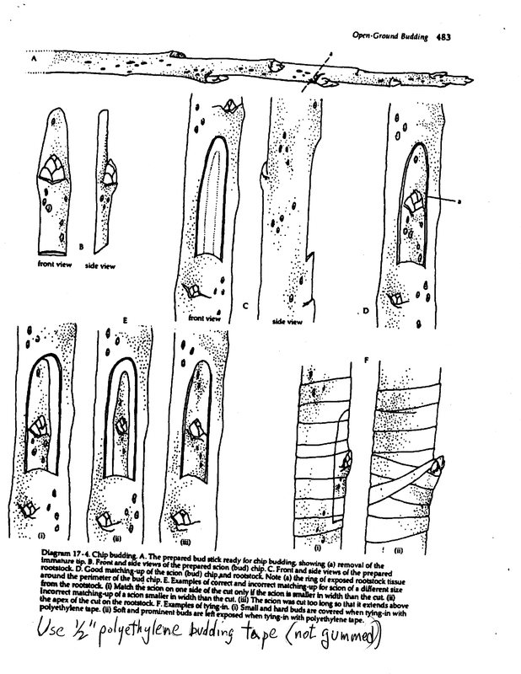

- Below is an outstanding description of the chip budding process with photographs of both growing-season chip buds (usually done in August when buds are mature) and dormant chip buds. Note the presence of a “handle” from the leaf in in first two pictures which are of a growing-season chip bud.

Chip Budding

Application:  An important method for propagating temperate fruit and ornamental shade tree species including apple and cherry, and many other species. In apple nursery stock production field, chip budding is gaining popularity over T- budding for several reasons:  - more rapid graft union formation  - higher % take  - reduced susceptibility to the fungal disease apple canker (Nectaria sp.)  - extended budding season since bark need not be slipping as in T-budding  - greater cold hardiness  - greater uniformity and growth from the bud. | 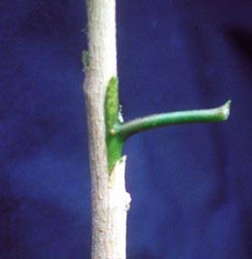

Timing:
Field Chip budding of apple is usually performed during the late summer or early fall, although at Cummins Nursery they chip bud onto bare root understock, at the beach, in February, then cold store at SOC, and line out in the spring.
How to Chip Bud:
The bud should be cut from the bud stick starting at the top and passing downward to a point about 0.5 to 1.0 cm below the bud, passing through the bark and into the underlying wood. A second cut is made below the bud at a slight downward angle to intersect the first cut. | 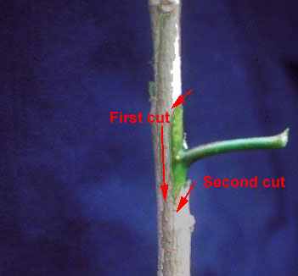
This drawing illustrates how the bud should be cut from the top down, but it was originally used in the Cyclopedia of Horticulture by LH Bailey, 1928, to illustrate how not to cut a T-bud, which should be cut from the bottom up. | 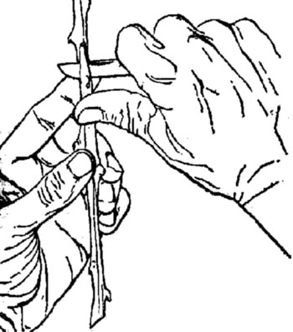
Cutting the rootstock | 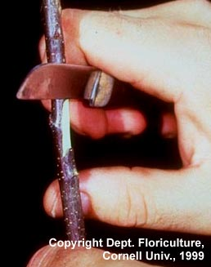
Placing the bud | 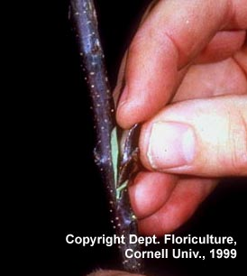
Aligning the cambia of scion bud and stock | 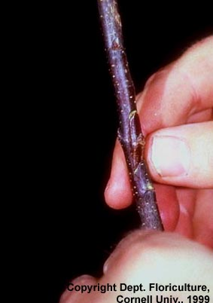
Chip bud wrapped with plastic wrap. More typically it is wrapped with a budding rubber.
The above article from Cornell University can be found online at:
https://courses.cit.cornell.edu/hort494/mg/methods.alpha/ChipMeth.html
- Read pages 519-521 in Chapter 13 of Hartmann and Kester's Plant Propagation. This section covers the chip budding technique. Pay special attention to the "Spring Budding" technique, which uses dormant scion wood for buds (last year's one-year wood) that are placed on rootstock just before bud-break. The other chip budding techniques are executed during the growing season on growing rootstock and with buds from growing, current-year wood. Be sure to read the captions of the diagrams and pictures, especially look closely at picture (i) down at the bottom of page 520. Here is the link to Chapter 13:
http://aggie-horticulture.tamu.edu/faculty/davies/pdf%20stuff/ph%20final%20galley/M13_DAVI4493_08_SE_C13.pdf
- Two other ag school bulletins have sections on chip budding that are also helpful. Check out ​Reproducing Fruit Trees by Graftage: Budding and Grafting (from U. of Kentucky Extension), Figure 3 on page 3. Also look at Figure 14 on page 10 in Grafting and Propagating Fruit Trees (from Penn State Extension).

